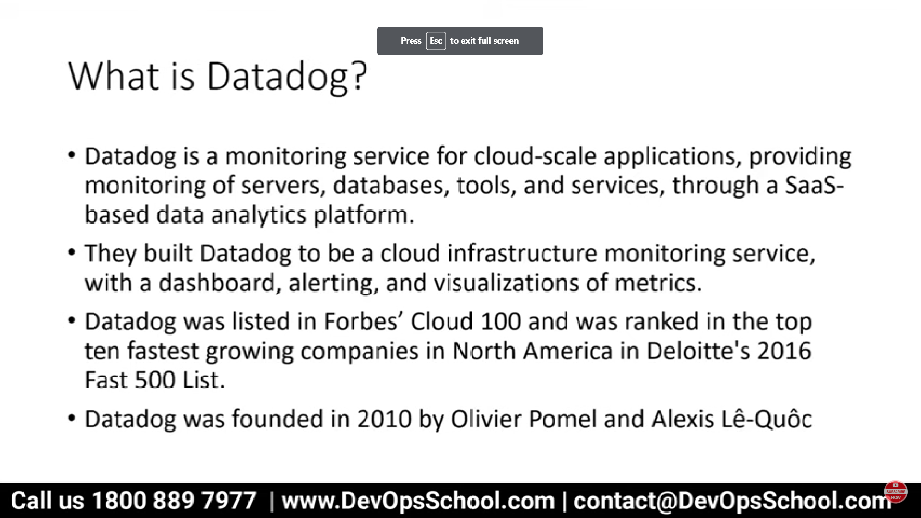

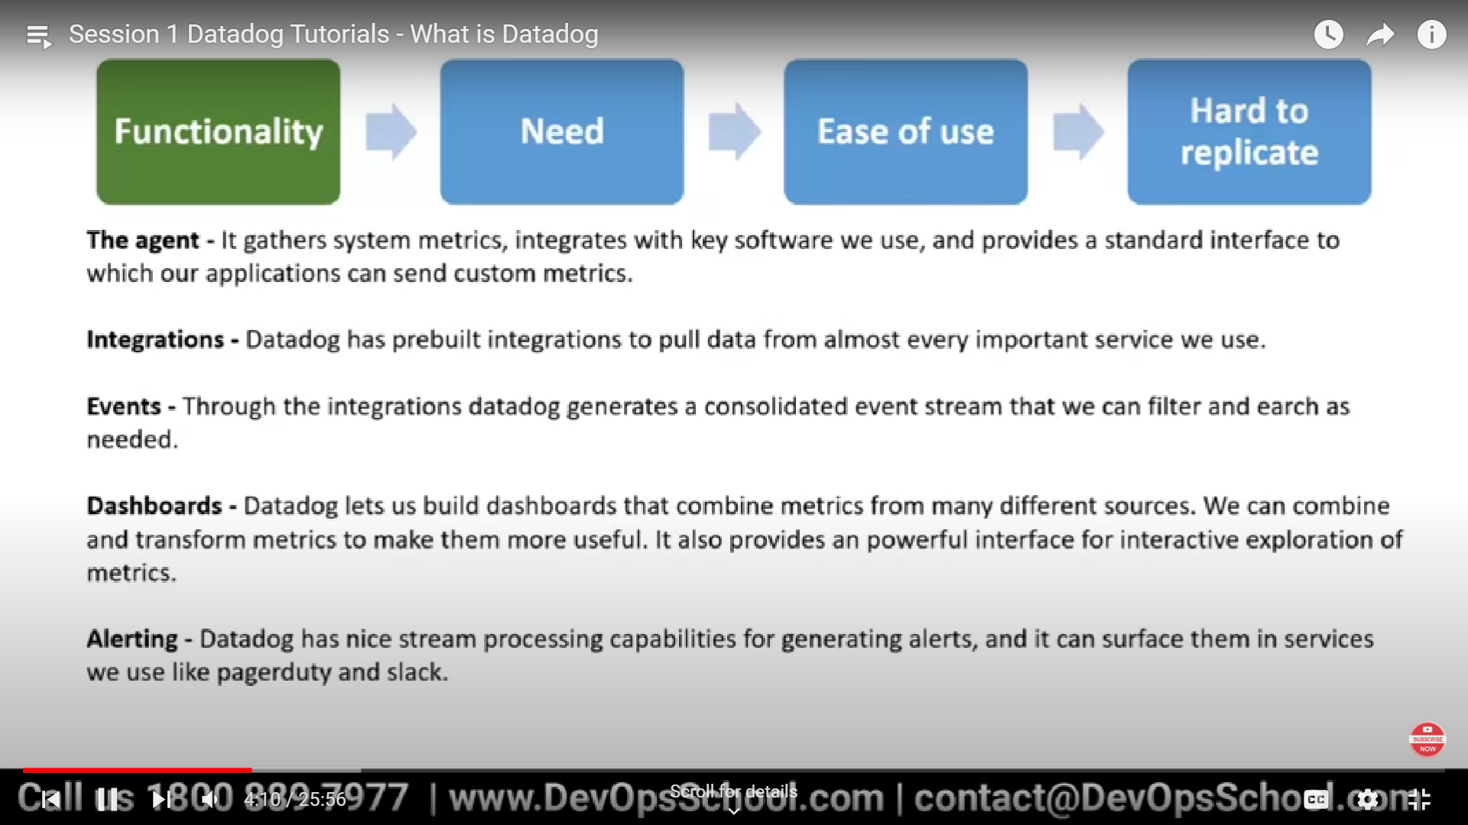

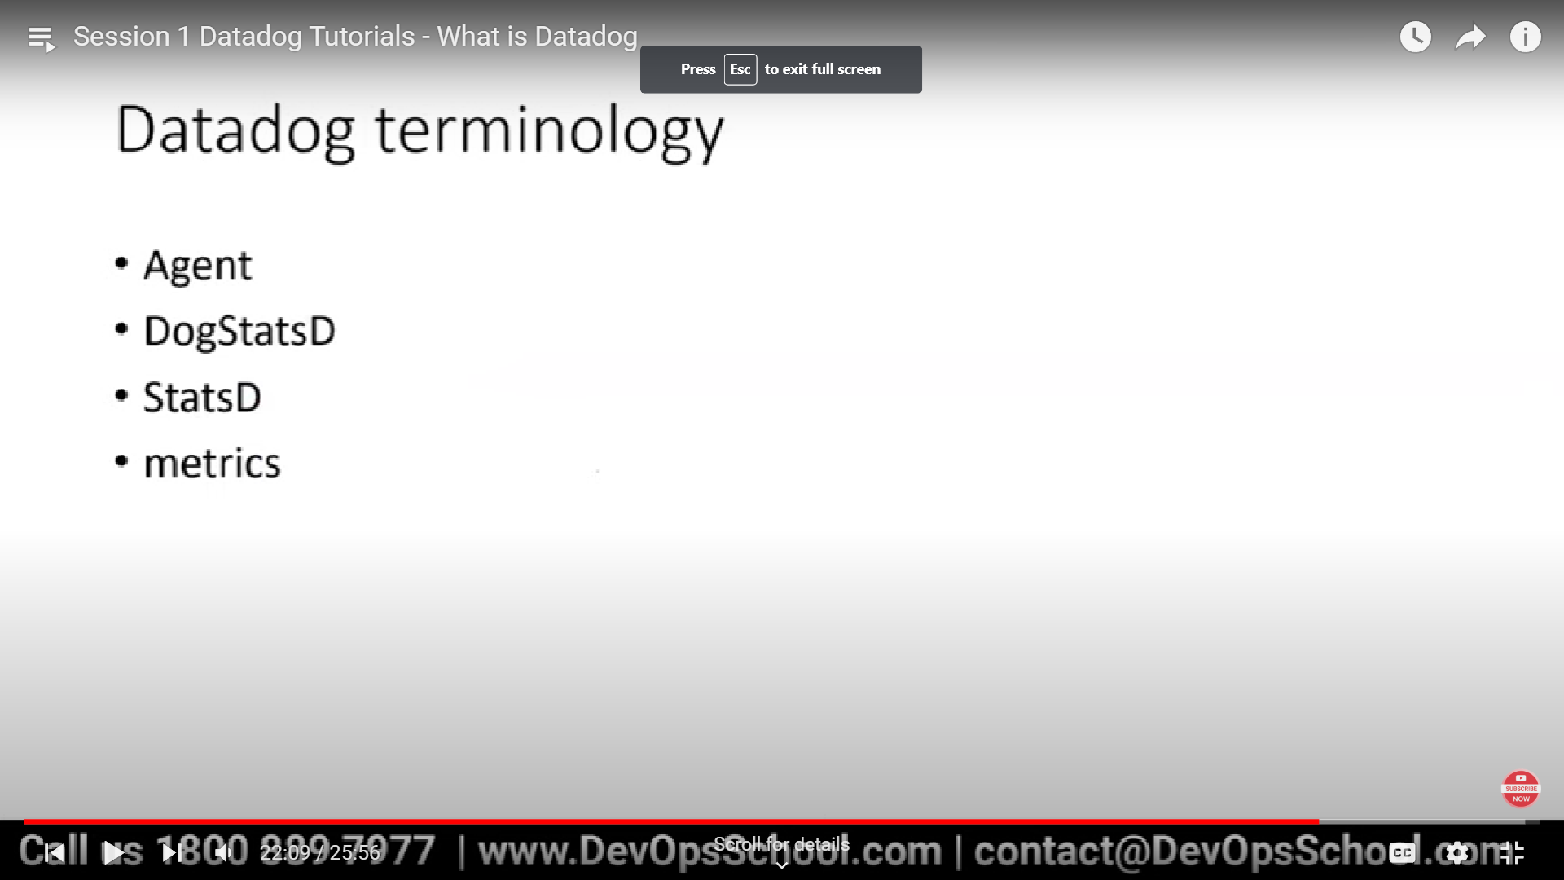

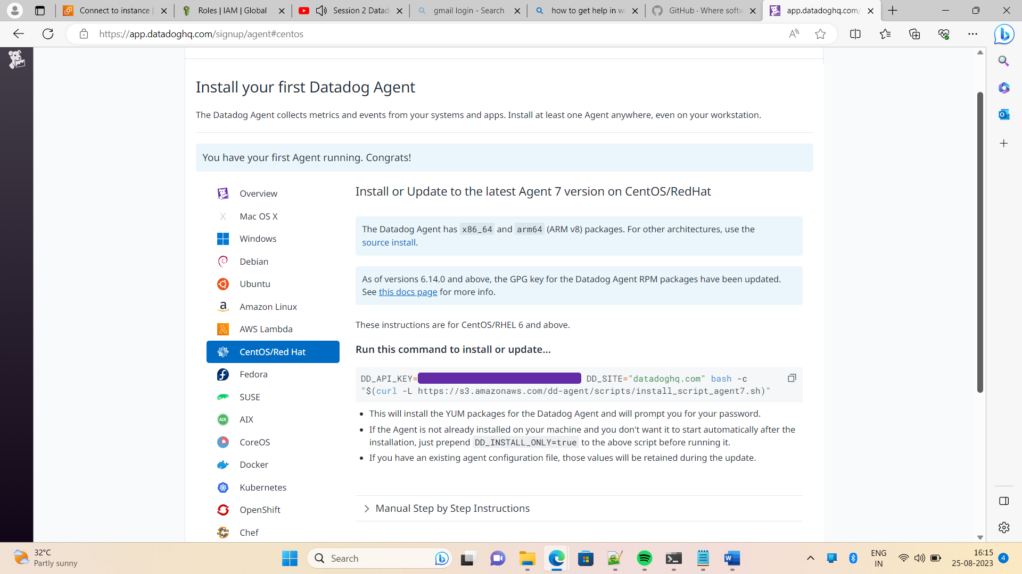

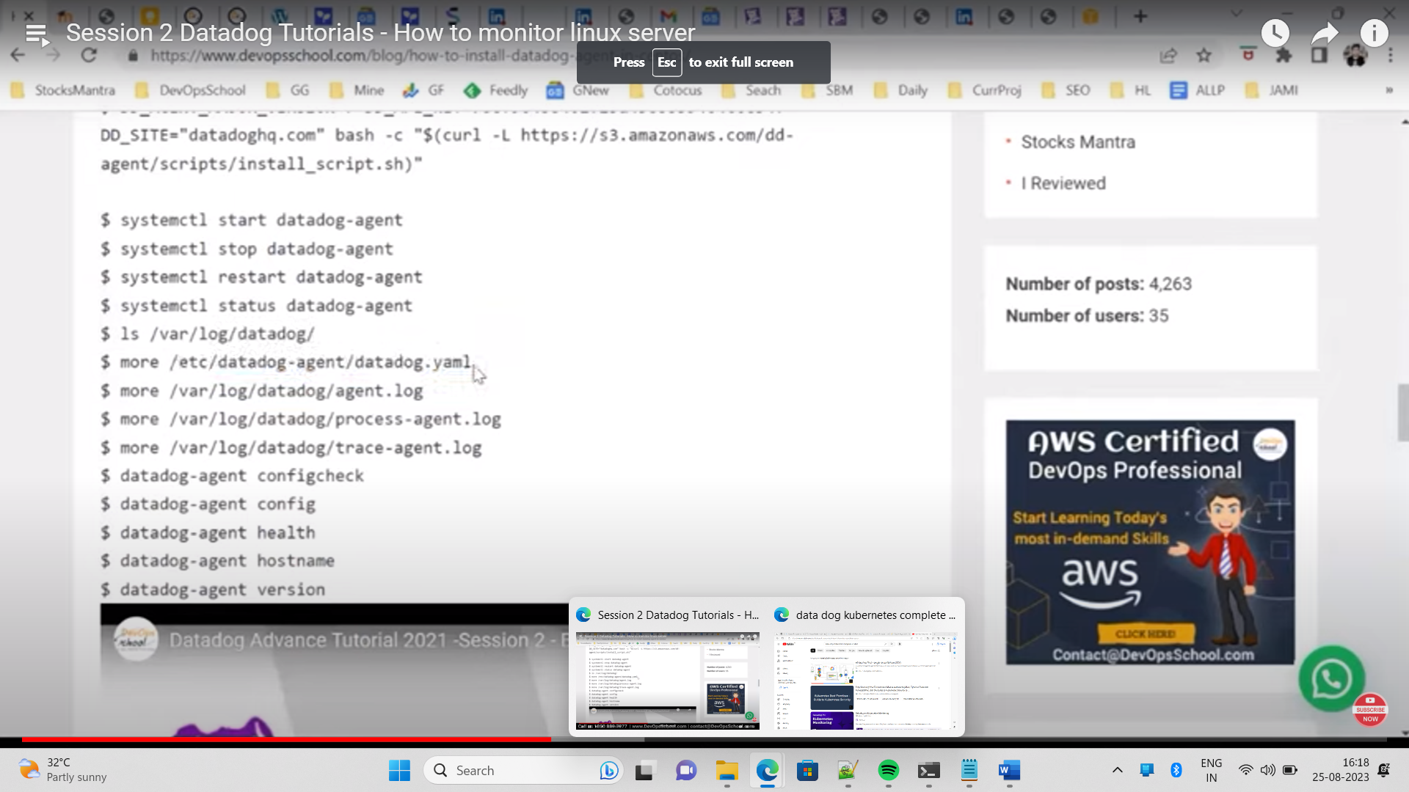

Check in datdog server

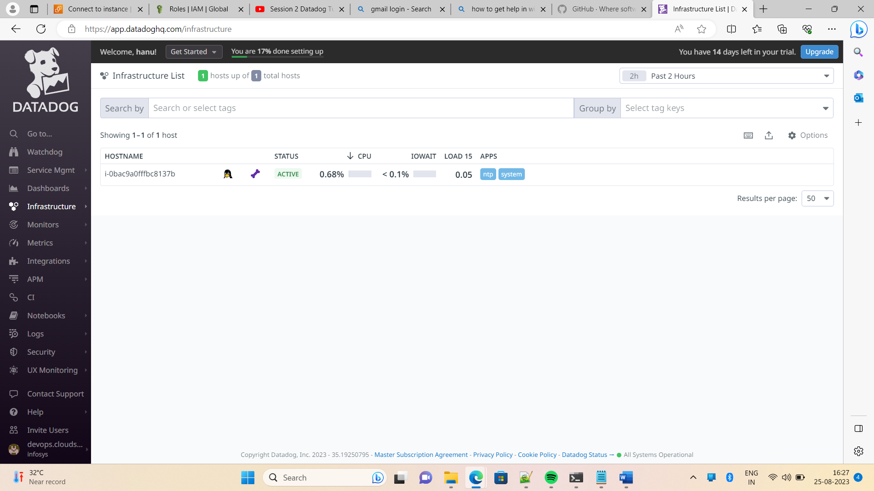

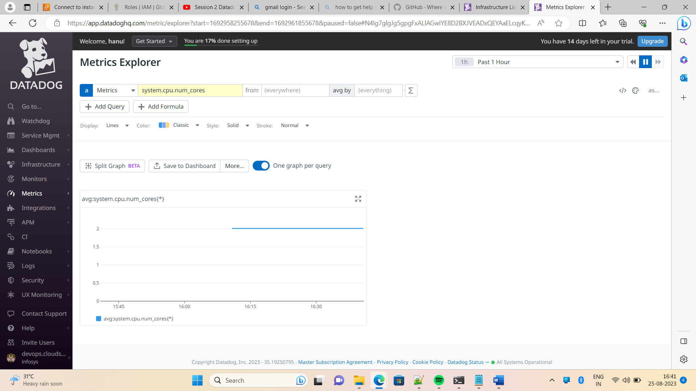

Process ie enabled

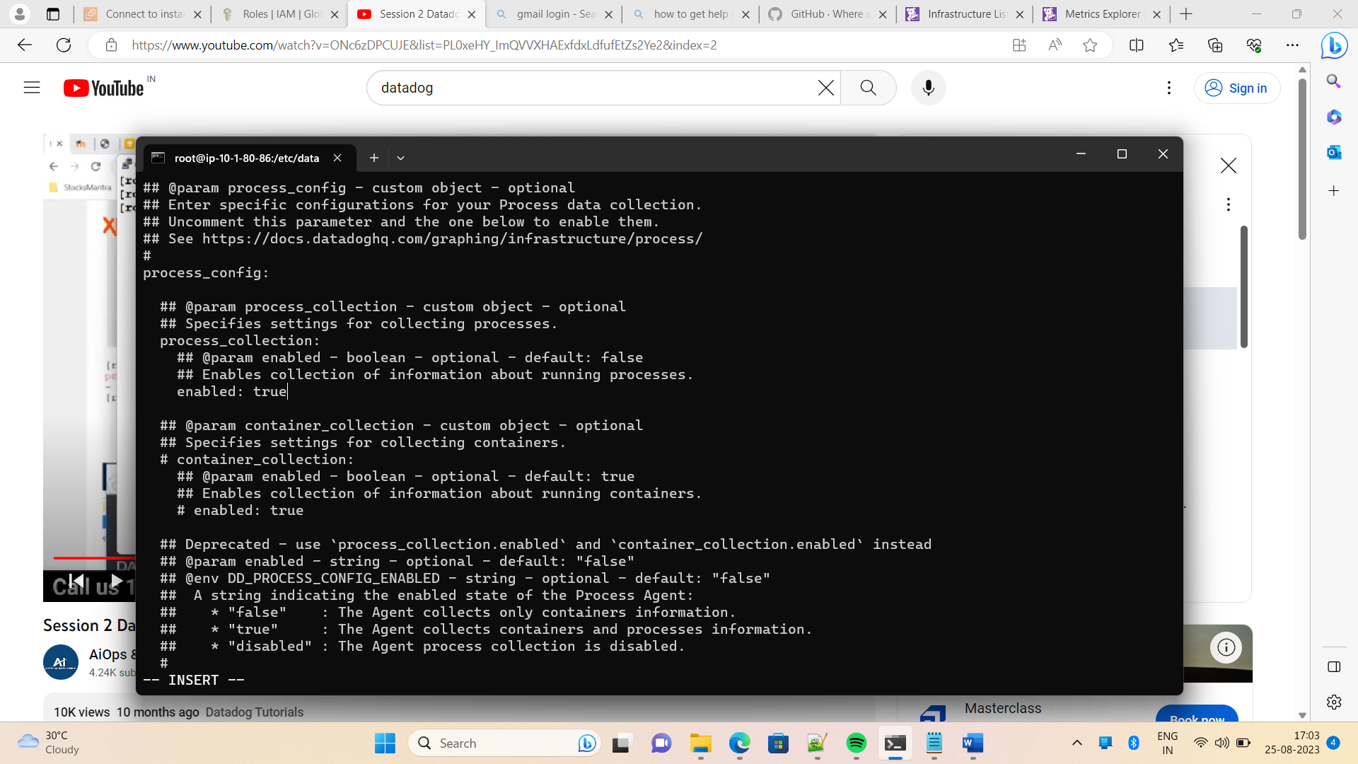

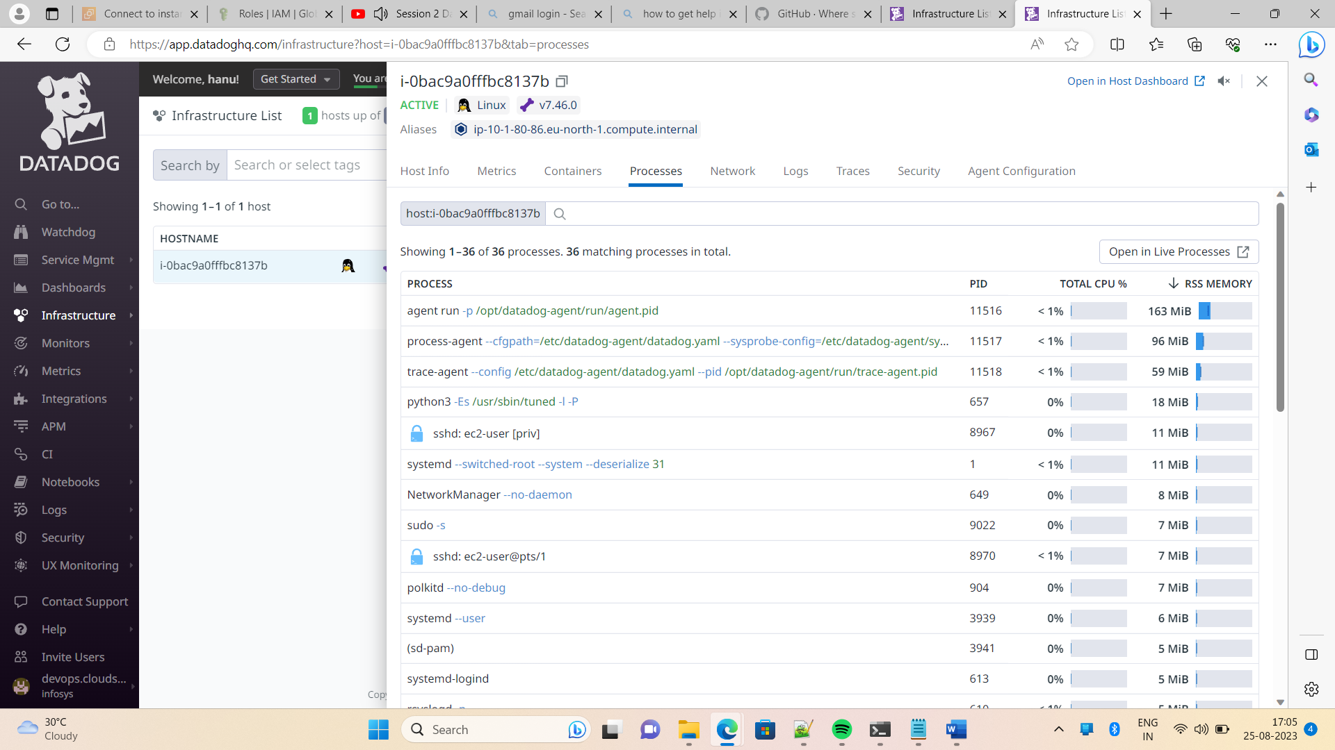

Lets check the python process. The python is already installed in your host

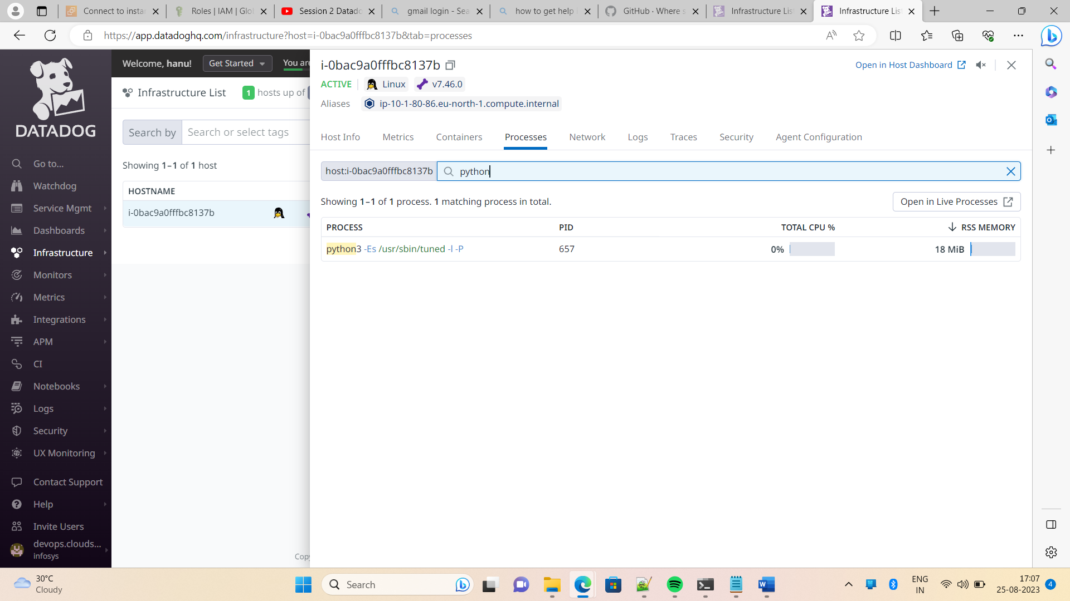

Datadog moniroring the Kubernetes cluster

Monitoring the Kubernetes cluster is very important make sure the application is up and running . you have to install the datadog agent in each worker node . basically it will collect thedefault metrics of pod like cpu utliztion , memory utilization and capture to data dog dashboard. In data dog create own dasboards,alerts and nic1e visulazation for the metrics

If you customize custom metrics for your dotnetor java application using the libraries and send to data dog]

